# A PROJECT REPORT ON

**“STUDY BOT - FLOW LEARNING”**

SUBMITTED TO MIT SCHOOL OF ENGINEERING, LONI

**BY**

Tejasvi Patil – MITU20BTIT0069

Keerti Satpute – MITU20BTIT0033

Sushant Sharma – MITU21BTITD012

Krishnaprasad Awala – MITU21BTITD006



**Under the guidance of**

**Prof.Rohini Bhosale**

**Department of** **Information Technology**

**MIT School of Engineering**

**MIT Art, Design and Technology University, Pune**

**MAEER’s Rajbaug Campus, Loni-Kalbhor,**

**Pune 412201**

**2020-21**

**ACKNOWLEDGEMENT**

I express my profound thanks to my Guide **Prof. Rohini Bhosale**

for her expert guidance, encouragement and inspiration during this Dissertation work.

I sincerely thank to **Prof. Dr. Rekha Sugandhi**, Head, Department of Information Technology, MIT School of Engineering, MIT-ADT University, Pune, for providing necessary facilities for completing the project.

I am grateful to **Prof. Dr. Kishore Ravande**, Principal, MIT School of Engineering, MIT-ADT University, Pune, for providing me the facilities to carry out my project work.

I also thank all the faculty members in the Department for their support and advice. I am very much grateful and thankful to my Parents for their immense love, affection, help, cooperation and encouragement to complete this course.

Finally, a special thanks to all my classmates and friends who helped and

encouraged me to complete successfully my project work.

Group member names

Tejasvi Patil

Keerti Satpute

Sushant Sharma

Krishnaprasad Awala

# ABSTRACT

Study bot is a text based conversation which provides user a better output. It provides guidance to the user for better search engine. It includes the right level of personalization. It is a tool which suggests the option to the user. Just like a online study platform smart bot provides notes syllabus and study materials to the students. It provides free-flow learning to the user. Now-a-days User interfaces for each and every applications are coming in a various formats like command-line, graphical, web applications and voice. Study bot application may serve the need of multithreaded connectivity. A study bot is used to make conversation between humans and machine through text based format. Study bot can also be robot that automatically analyses the user’s queries and then answers them. Developing a chat bot for a university can help both the students as well as the management and can be further integrated with the university website for making services available for large number of audience.

**TABLE OF CONTENTS**

**Title 1**

**Acknowledgement 2**

**Abstract**  **3**

**Chapter 1. INTRODUCTION 6**

1.1 – Project Introduction **7**

1.2 – Project Profile **8**

1.3 – Project Purpose **9**

1.4 – Project Scope **9**

**Chapter 2. SYSTEM REQUIREMENT ANALYSIS 10**

2.1 – Problem Statement **10**

2.2 – Highlights **11**

2.3 – Advantages **12**

2.4 – Limitations/Disadvantages **12**

2.5 – Design/Implementation **12**

2.6 – Tools And Technologies **13**

2.7 – System Requirements **14**

2.8 – Hardware Requirements **15**

2.9 – Architecture **16**

2.10 – Use Case Diagram **18**

2.11 – Data Flow Diagram **19**

2.11.1 – Level 0 **19**

2.11.2 – Level 1 **19**

2.11.3 – Level 2 **20**

2.12 – Testing / Result **21**

2.12.1 – Website **21**

2.12.2 – Chatbot **28**

**Chapter 3. CONCLUSION 32**

3.1 – Conclusion And Future enhancements **32**

**Chapter 4. REFERENCE 32**

4.1 – Reference/Annexure **32**

# INTRODUCTION

* 1. Project Introduction
  2. Project Profile
  3. Project Purpose
  4. Project Scope

# 1.1 PROJECT INTRODUCTION

A study Bot is a software tool that interacts with users on a certain topic or in a specific domain in a natural, conversational way using text .The study bot is an agent where the computer program is designed to have an intelligent conversation with the user and provide the appropriate response. Study bot is fully functioning, semi-autonomous systems that can assist students. The use of study bot in academics helps students in getting instant replies and help for their queries, And Also getting all the required study materials at one place without consuming more time.

Study bot is one of many great promises in information technology. It is conceived as a new interface, designed to replace or complement applications or visits to a website by having users simply interact with a service through a chat. In most cases, study bots can be used to give basic lectures. The objective is that study bots can serve as virtual advisors, as well.

In our project we explore how a study bot can give information to students about study material related information. In the first iteration of the project we created a study bot for giving students information about semester wise syllabus and study material of respective subjects. In the second iteration we wanted to explore the use of studyBot through theory and used this in combination with testing to learn more about how a studybot for this context should be. In final iteration our plan is to evaluate the studybot.

Study bot machine has embedded knowledge to identify the sentences and making decision as to answer a question. Study bots are usually stately services, it remembers the previous information or commands and processes them in order to answer any query. When study bot applications are integrated with popular web services they can be used by a large audience. This Student study bot system provides answers to the queries of the user by analyzing them. The university inquiry study-bots will be built using artificial algorithms that analyze user's queries and understand user's message. The response principle is to match the input string from a user. The System analyses the question and then answers the user.

# 1.2 PROJECT PROFILE

|  |  |
| --- | --- |
| Project Title | Study Bot – Flow Learning |
| Project Category | Web Application |
| Objective | The Main Objective Of The Website Is to Create An E – Learning Platform For Students Who Are Struggling With The Resources And Material. |
| Programming Languages | HTML, CSS, Bootstrap |
| Tools | Visual Studio Code, Figma, Photoshop |
| Documentation Tool | Microsoft Office 2019 |
| Guide | **Prof.** Rohini Bhosale |
| Developed By | Tejasvi Patil, Keerti Satpute, Sushant Sharma,  Krishnaprasad Awala |

# 1.3 PROJECT PURPOSE

As Students We Have Always Faced Issues Regarding Material And Notes Before Exams, So To Solve The Issue We Have Come Up With The Idea of Study Bot.

The Main Purpose of Our Project Study Bot – Flow Learning Is To Solve Student’s Problems Related To Learning, By Giving Them All the Resources And Material They Need In One Place.

# 1.4 PROJECT SCOPE

In Our Project We Explore How To Provide Study Related Information To Students, By Creating a Website For Giving Students All The Material And Resources They Need For Better Learning.

Information Given By The Web Bot Would be Useful For New Students As We Give Them Information We Consider to Be Important, We Wanted To Explore The Use Of Website Through Theory And Use This In Combination With Testing To learn More About How Websites For This Context Should Be.

# SYSTEM REQUIREMENT AND

# ANALYSIS

# 

# 2.1 Problem statement

# Problems

### **Problem 1**

User faces difficulty in various websites generally having Confusion regarding topics to be found out.

### **Problem 2**

With the advent in technology and with the perpetual increase in the strength of the students and the number of departments in the educational institutions, it is tough to exchange the study materials between the students and the faculties.

# Solutions

### **Solution 1**

Providing single search engine. It includes the right level of personalization. It is a tool which suggests the option to the user.

## **Solution 2**

Quick response because study bot is a software tool that interacts with users on a certain topic or in a specific domain in a natural, conversational way using text.

# 2.2 HIGHLIGHTS

Finding an educational chatbot is more challenging than discovering a mobile app or website.

* We found over 47% of chatbots misleadingly indexed in the educational category in the independent web directory.
* Mostly available chatbots on the Messenger deal with learning languages, economic topics, or multiple subject matter.
* Chatbots are using decision trees rather than artificial intelligence.

# 2.3 ADVANTAGES

Study Bot is an inexpensive, efficient and comfortable way for students to easily access notes and an easier alternative to study for exams students can easily find out about e learning source and syllabus related information in a single search engine. Also, users can find study material semester wise from the website.

Across the spectrum of education, whether for students or for teachers, the general benefits of bots are that they are quick to respond, are available round-the-clock, and can be made available on multiple channels. They can be molded to be assistants, administrators, tutors and more

**2.4 LIMITATIONS/DISADVANTAGES**

* Study Bot is currently limited to CS/IT Branches only And There Are Only Few Semester Avaialble
* Bot can only respond to user only to an extent they has been trained
* It cannot handle complex queries
* It doesn't have the ability to take a decision
* It will be having same answer for any query.
* It will only deliver a particular set of response

# 2.5 DESIGN/IMPLEMENTATION

The whole website is designed by using programming languages like HTML, CSS, Bootstrap and The UI/UX has been desined by using Figma, While certain icons and images have been created by using Photoshop

# 

# 2.6 TOOLS AND TECHNOLOGIES

|  |  |  |
| --- | --- | --- |
| ICON | TOOL | USAGE |
|  | Visual  Studio  Code | IDE |
|  | Figma | UI/UX Design |
|  | Photoshop | Logo, Icons And Other Artwork Design |

# 2.7 SYSTEM REQUIREMENTS

Software requirements deal with defining software resource requirements and prerequisites that need to be installed on a computer to provide optimal functioning of an application. These requirements or prerequisites are generally not included in the software installation package and need to be installed separately before the software is installed.

Recommended System Requirements

Web browsers like

• Chrome: 69.0.3497 or above

• Internet explorer: Internet explorer 7 or above

And A Good Internet Connection

# 

# 2.8 HARDWARE REQUIREMENTS

•The most common set of requirements defined by any operating system or software application is the physical computer resources, also known as hardware, a hardware requirements list is often accompanied by a hardware compatibility list (HCL), especially in case of operating systems.

• An HCL lists tested, compatible, and sometimes incompatible hardware devices for a particular operating system or application.

• There are many hardware requirements for any software or application. In the case of Study Bot these are the software requirements

• Recommended Donner Side Hardware requirements:

1. RAM: 500 MB
2. Processor: Octa-Core Max 1.40GHz
3. Hard Disk Space: 1 GB minimum required.
4. Computer with internet connection

• Recommended Server-Side Hardware requirements:

1. RAM: 4 GB.

2. Processor: Octa-Core Max 1.40GHz.

3. Hard Disk Space: 1 GB minimum required.

4. Computer with internet connection.

**2.9 ARCHITECTURE**

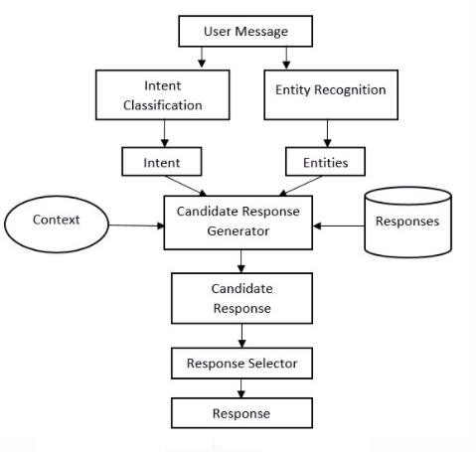

# 

# Ai Chatbots: Transforming the Digital World | SpringerLink

# 2.10 USE CASE DIAGRAM

**2.11 DATA FLOW DIAGRAM**

**2.11.1 LEVEL 0**

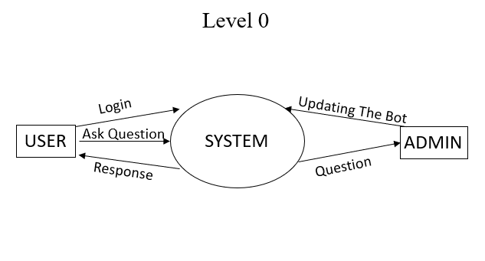

**2.11.2 LEVEL 1**

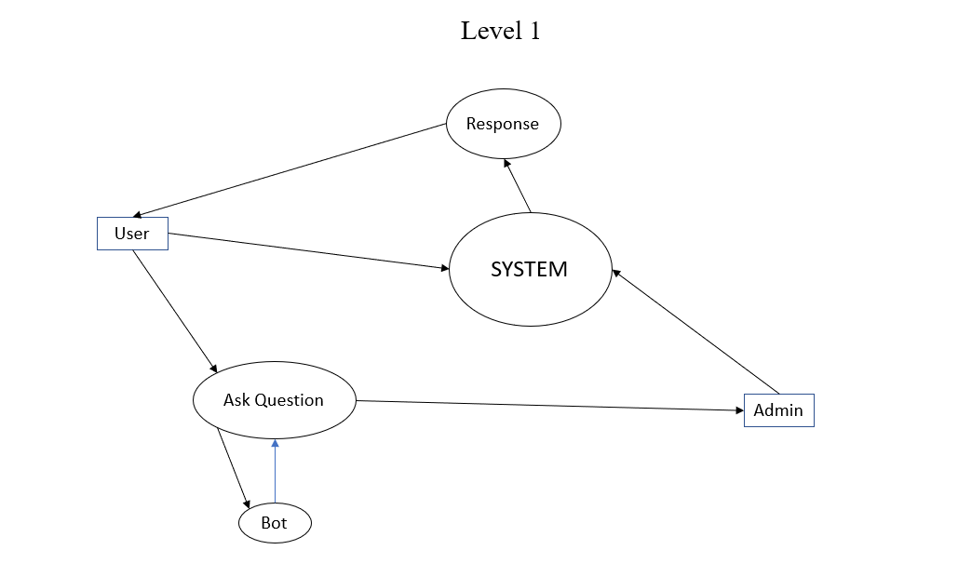

# 

**2.11.3 LEVEL 2**

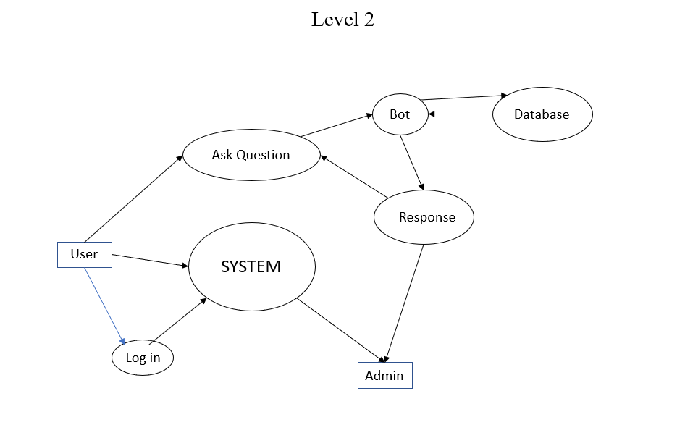

# 2.12 TESTING / RESULT

The Website Is functioning properly and we are able to receive the output we aimed for, that is being able to access the proper E – material.

# 2.12.1 WEBSITE

1: This Is How The Homepage Of The Website Looks Like

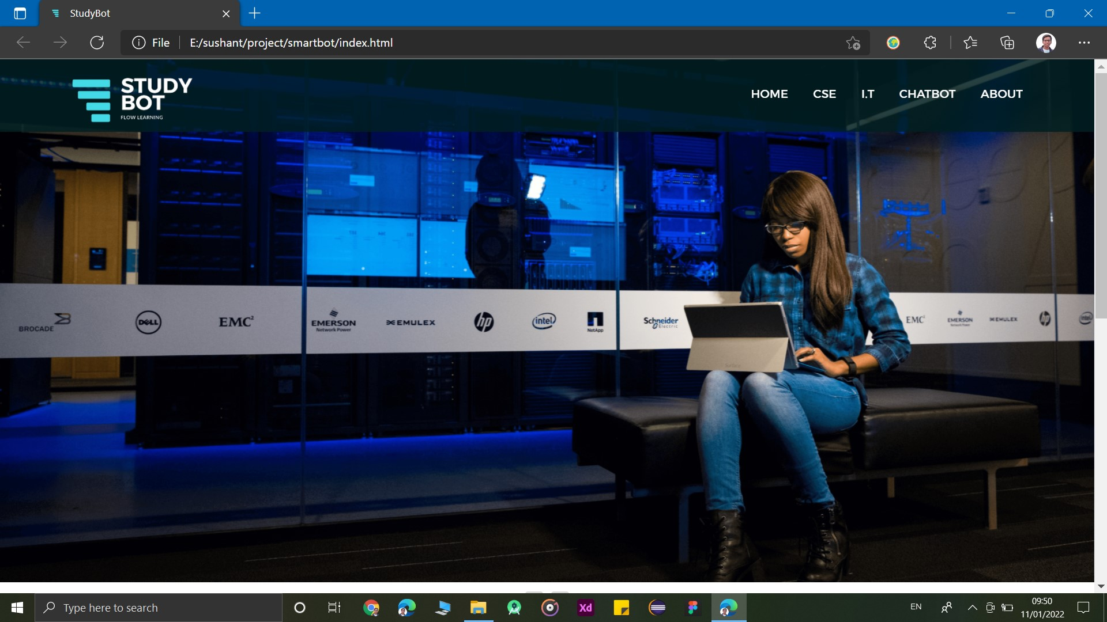

2: User Will Be Able To Choose Between Home, CSE, IT And The About Page

(Scrolled Down Image)

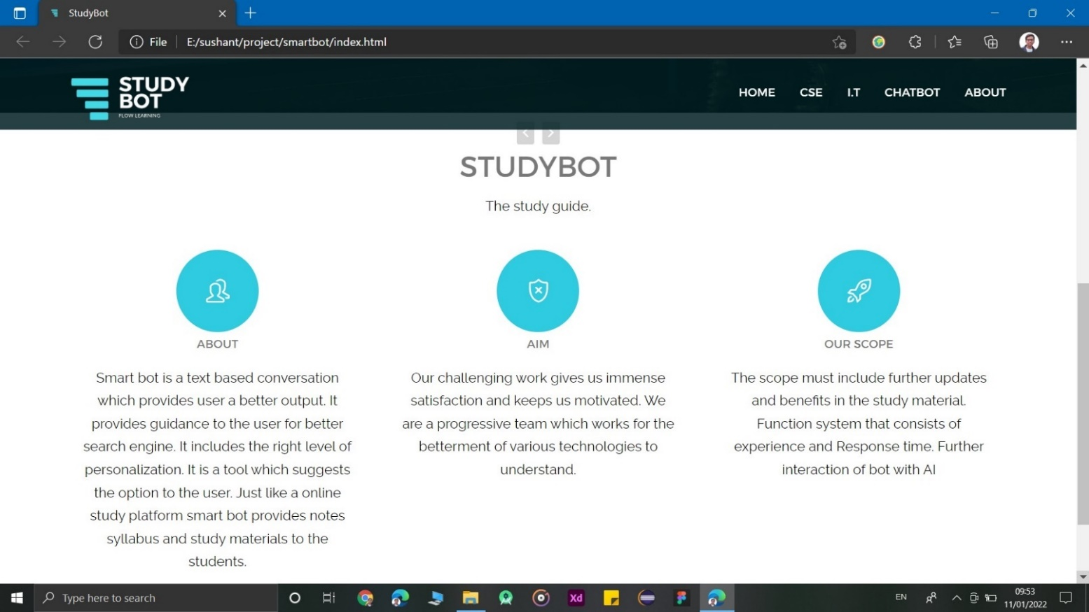

3: Once Clicked On IT, The User Will Be Able To See This Page. Where They Will Be Able to Choose Between The Semesters According To Their Need.

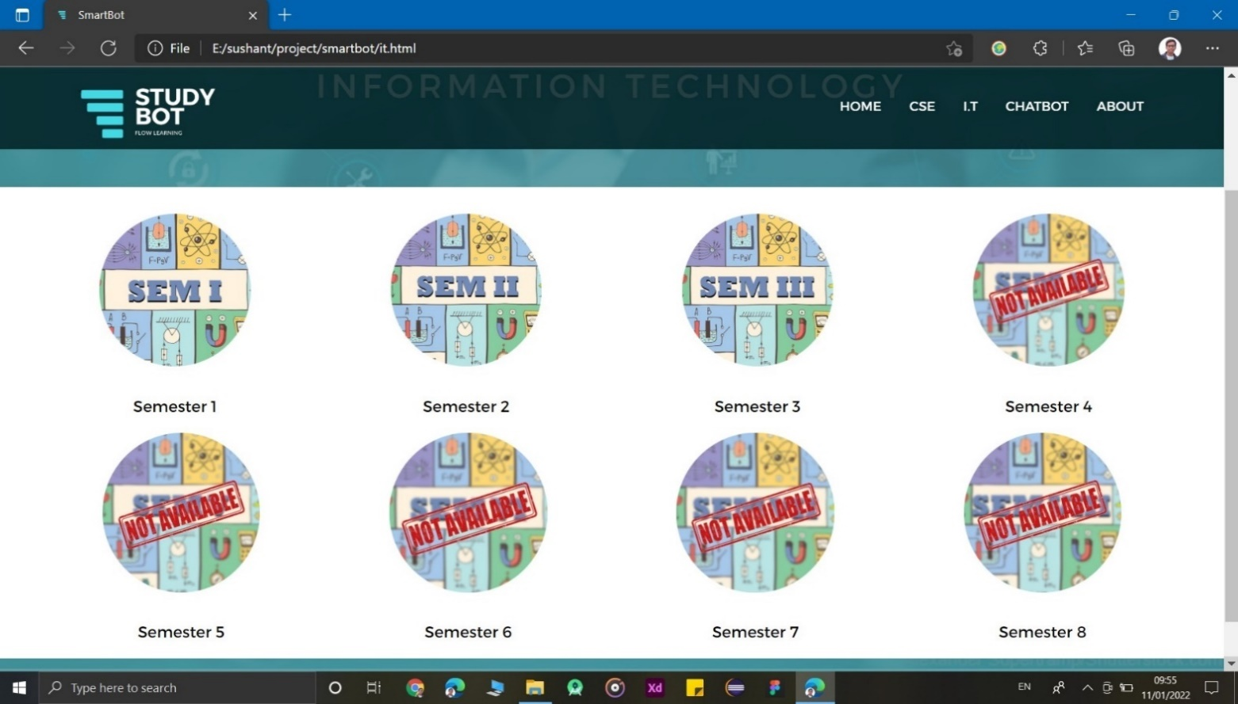

4: After Clicking On Any Semester Icon They Can Choose Between The Subjects.

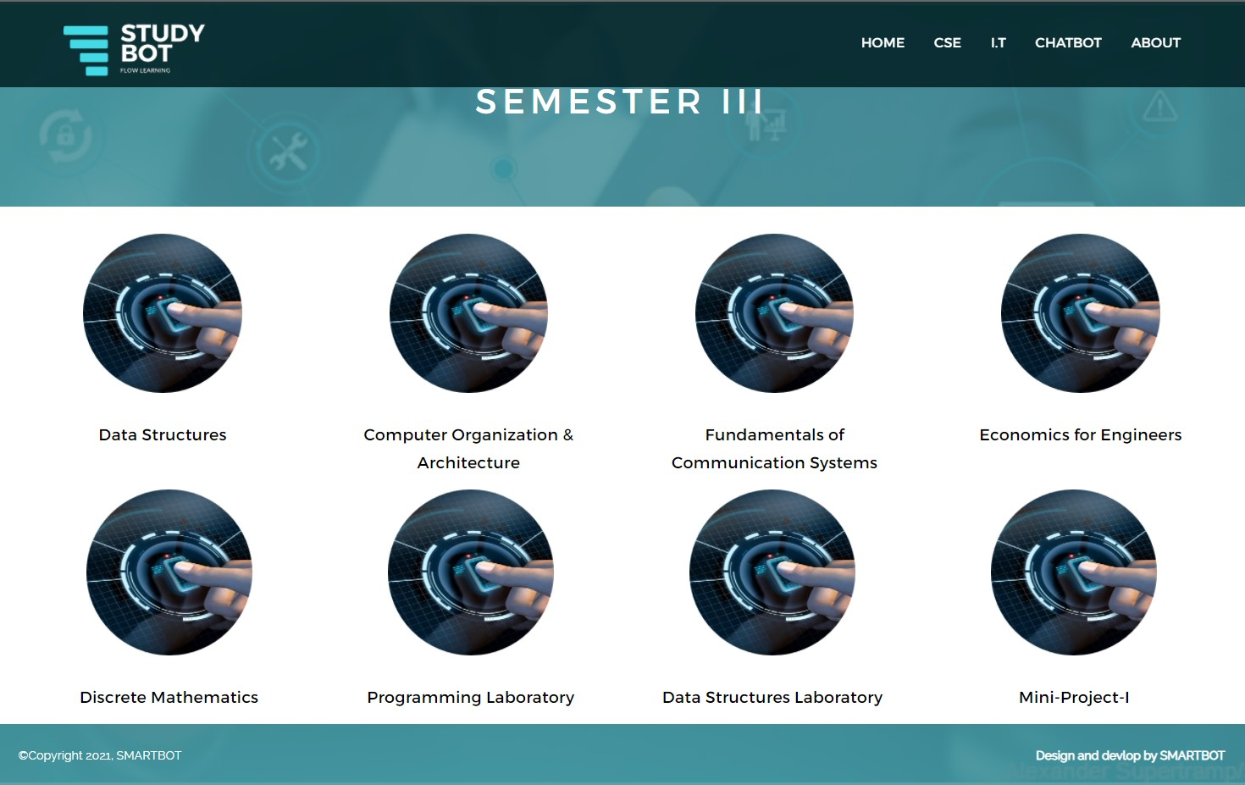

5: After Clicking On Any Of The Subject Icons They Can Choose Between The Units.

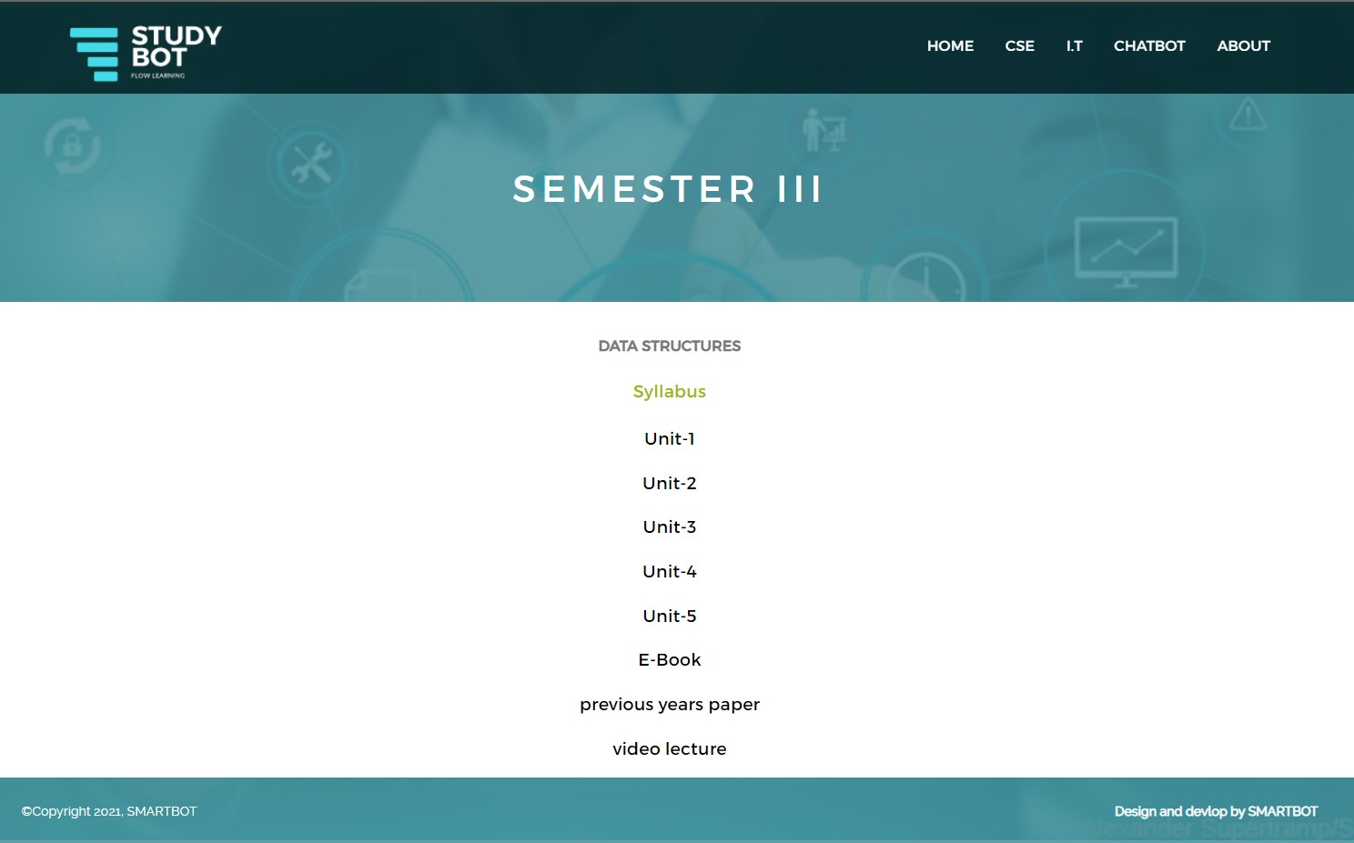

6: After Clicking On Any Of The Options They’ve Been Given, The User Will Be Redirected To A Google Drive Link With The Content.

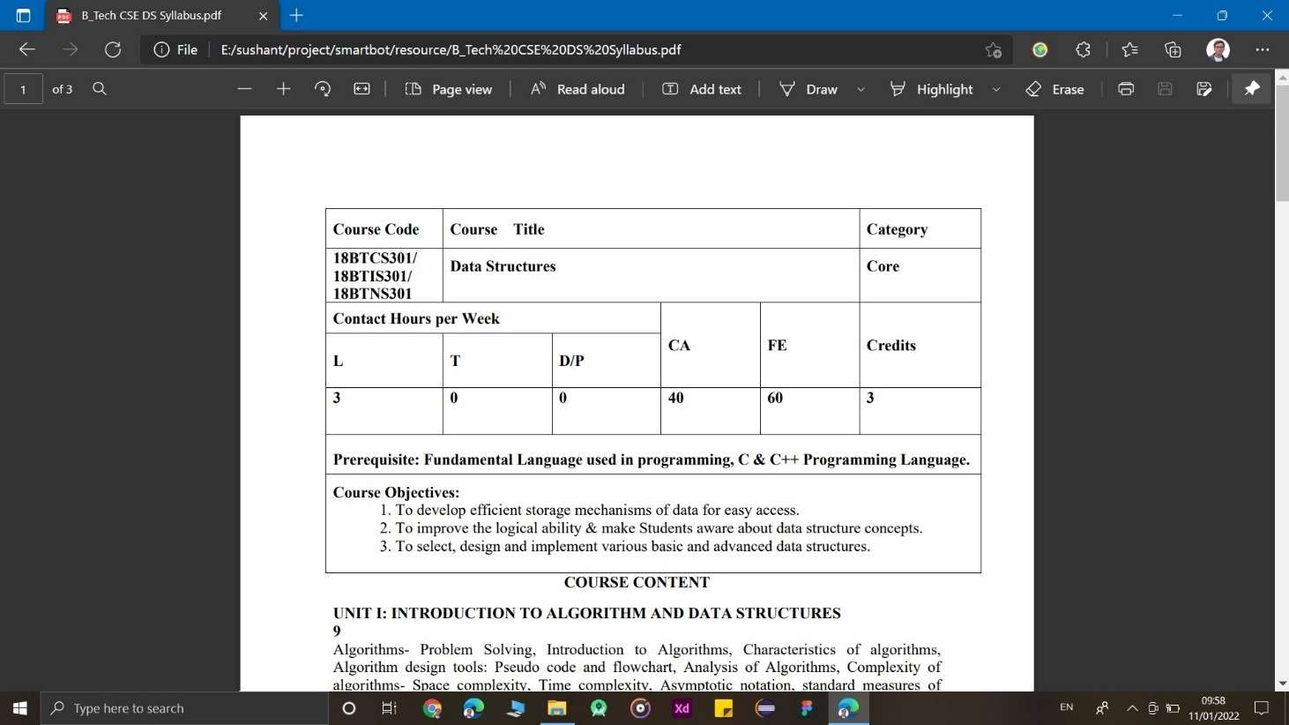

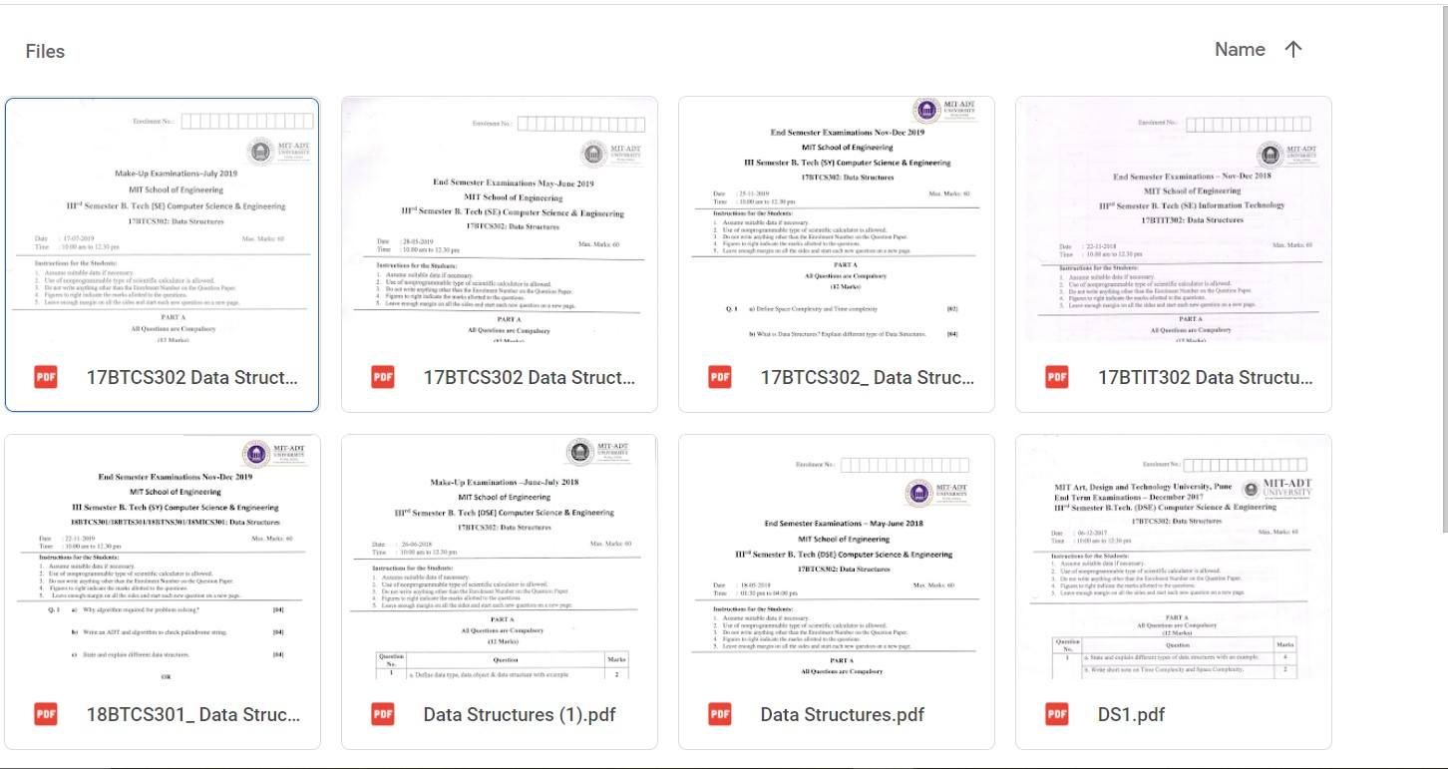

• About Page Of The Website:

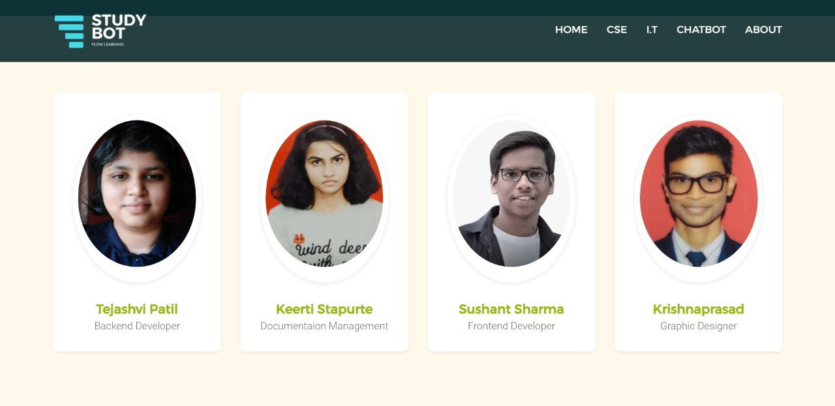

• To Make Things Even More Convenient, We have Come Up With a Chatbot

# 

# 2.12.2 CHATBOT

1: User Can Interact With The Chatbot By Typing Hello

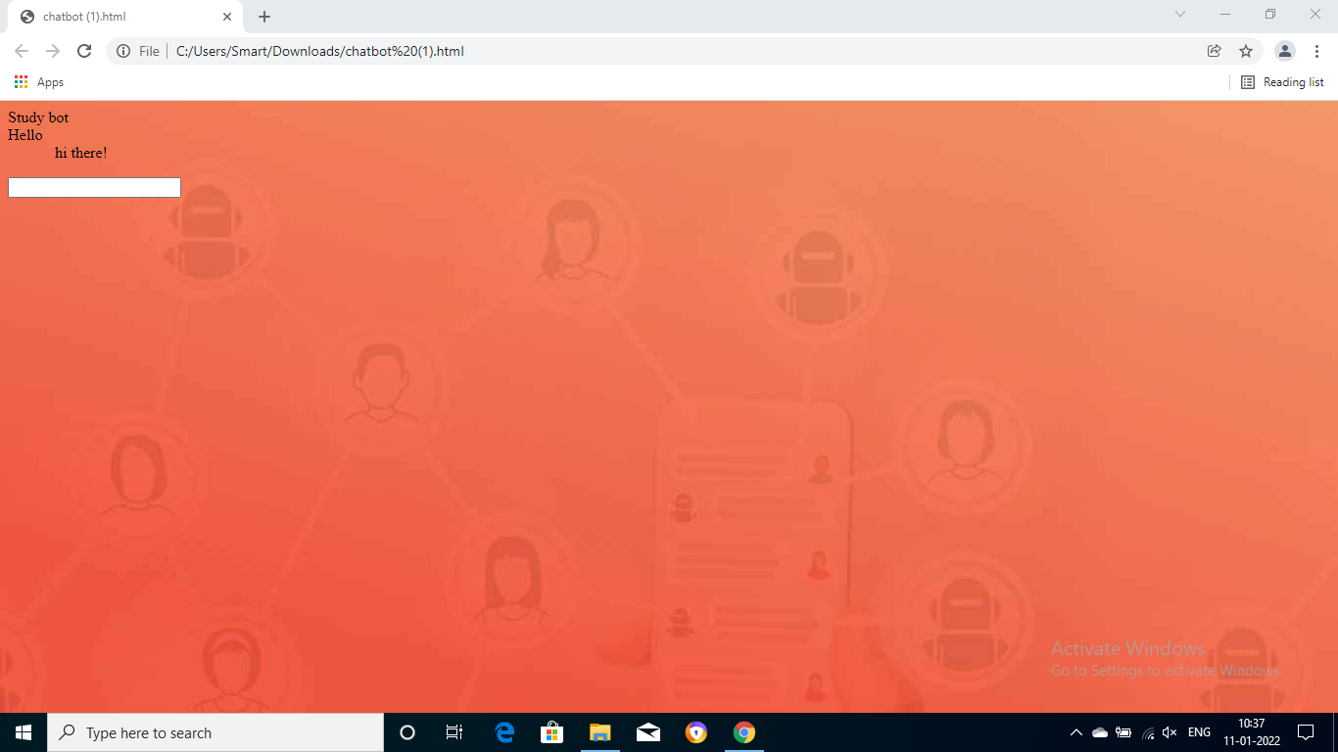

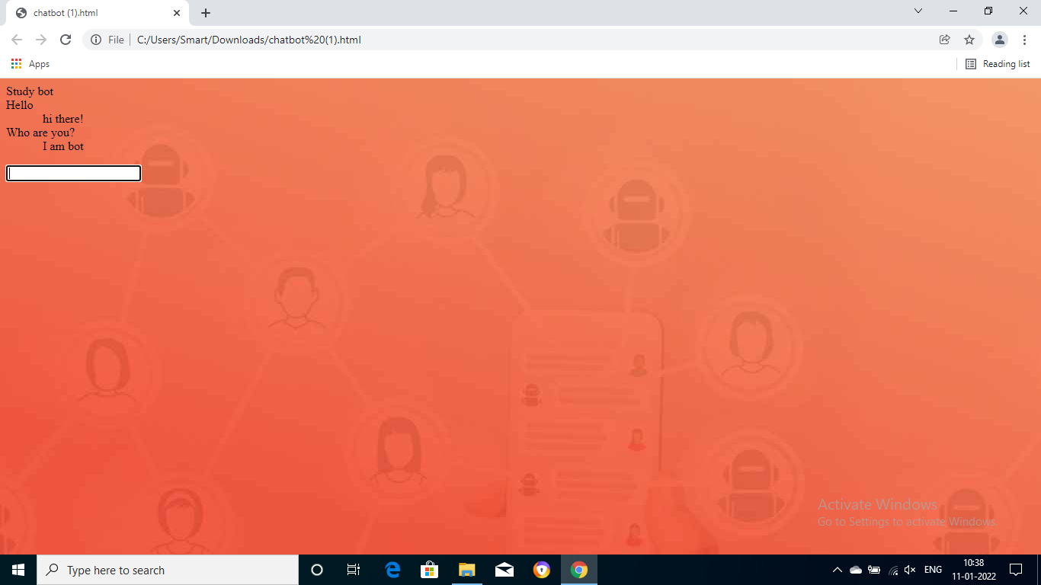

2: After Typing E-Resource User Will Be Asked The Year Of Study

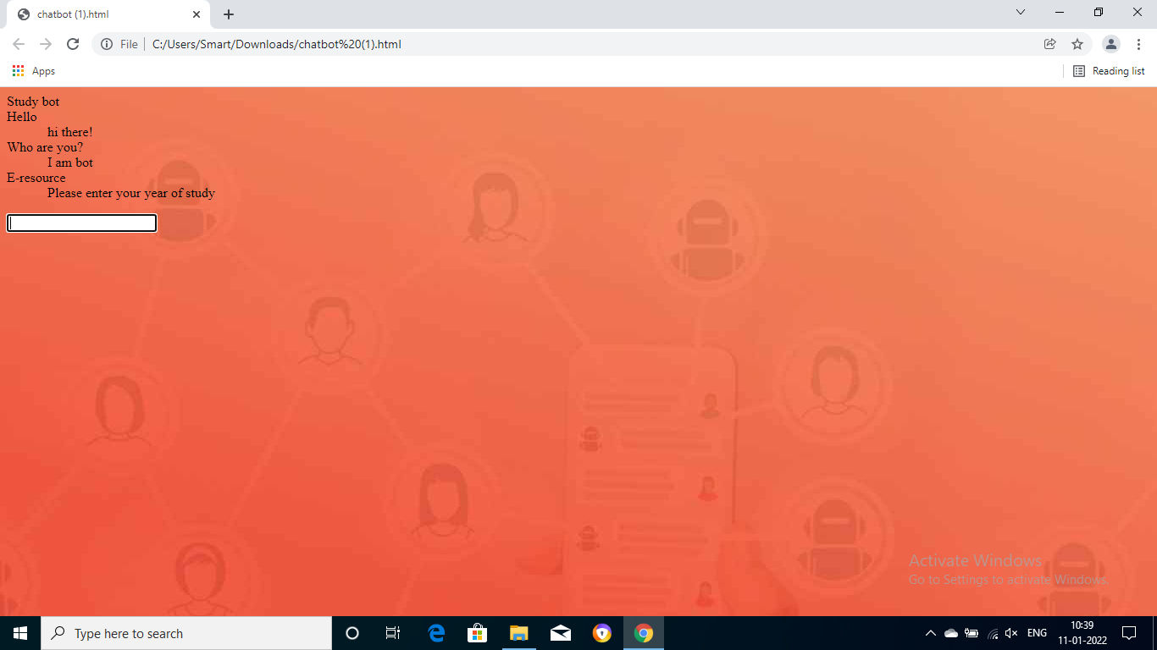

3: After Typing The year Of Study The User Will Be Asked IT/CSE

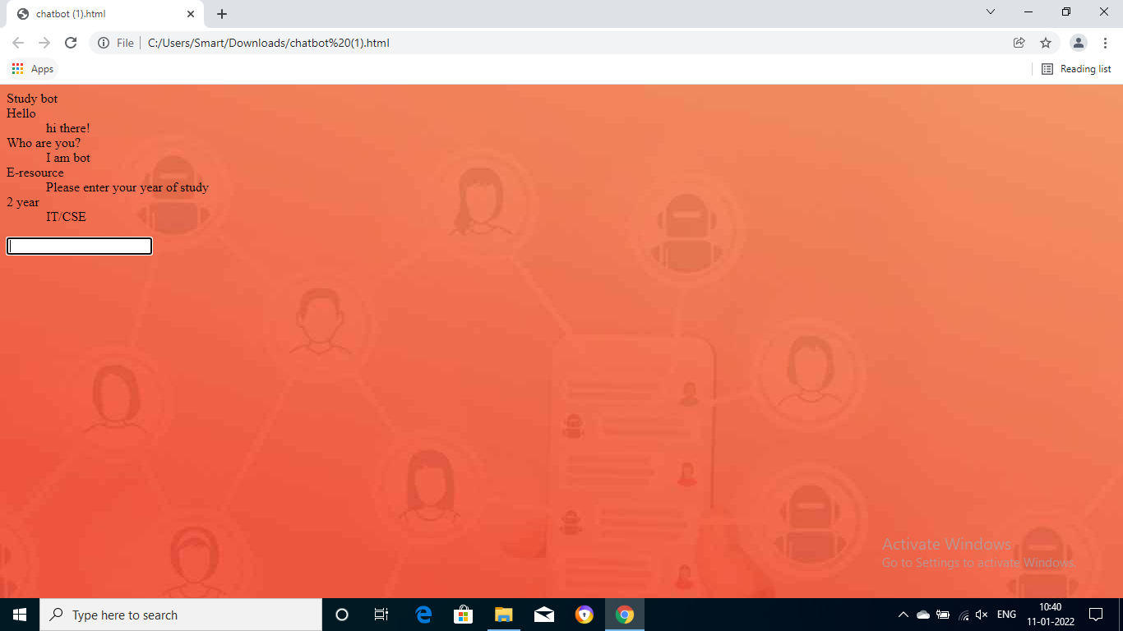

4: After Typing Their Branch The User Will Be Asked About Semester

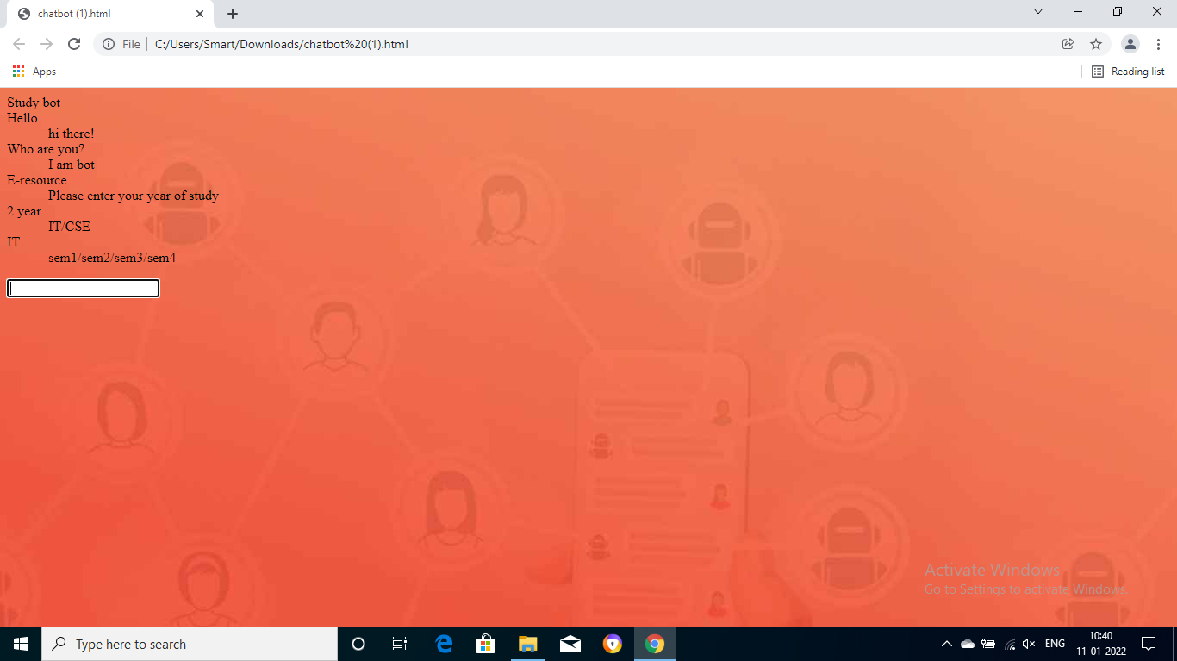

5: After Typing Their Semester The User Will Be Asked If The User Wants Syllabus / E – Resource

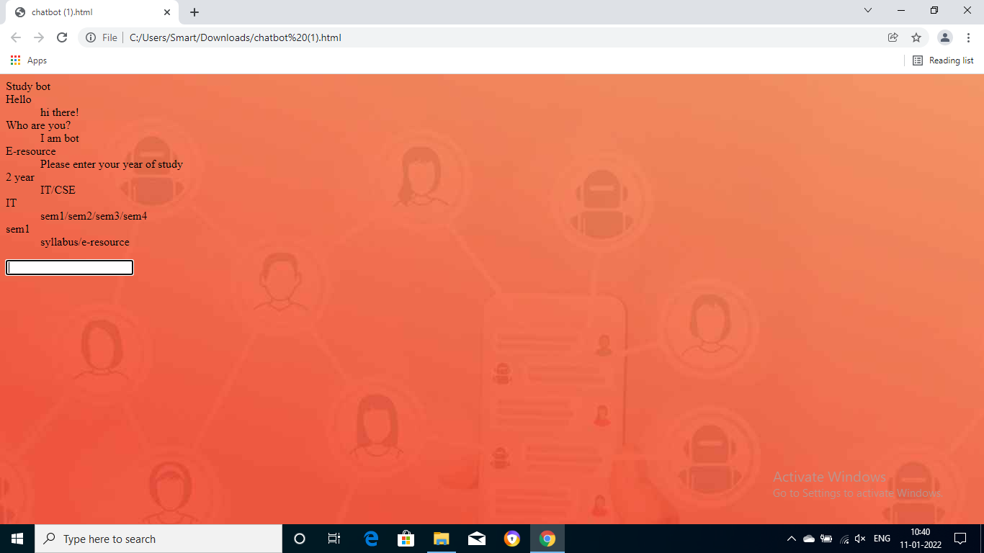

6: After Choosing The Subject A Short Syllabus Will Be Shown

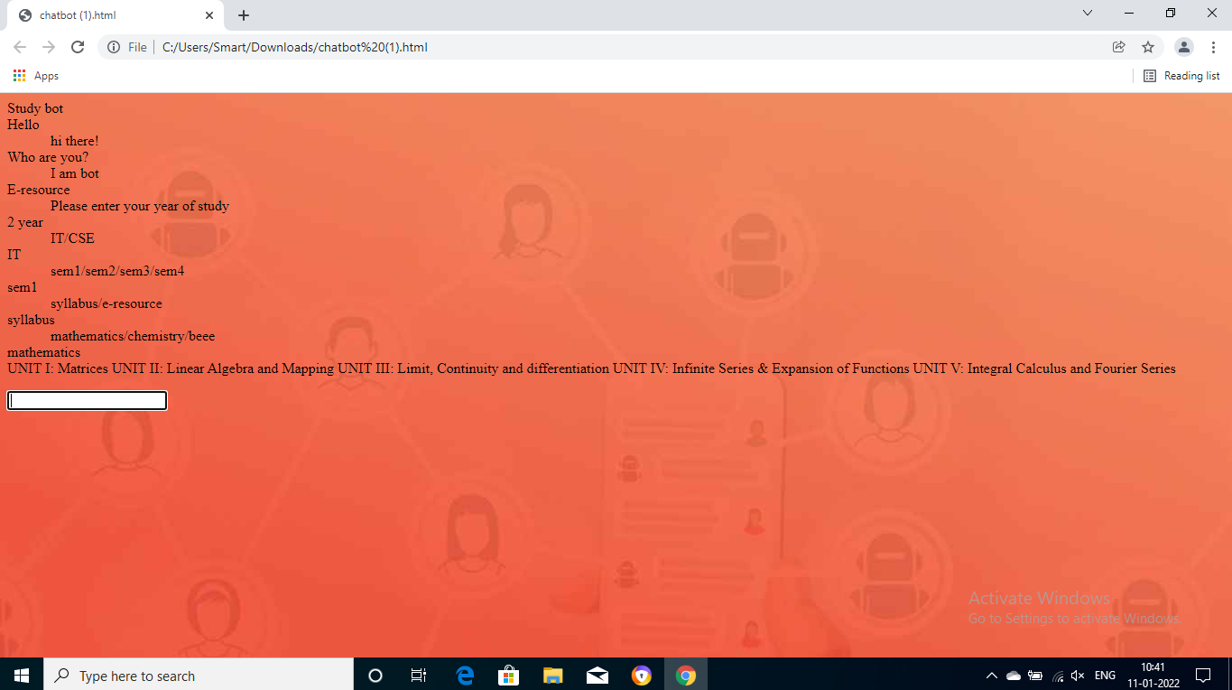

# 

# 

# 3 CONCLUSION

# 3.1 CONCLUSION AND FUTURE

# ENHANCEMENTS

In conclusion, using study bot technology in education settings to give personalized learning support as it led to positive learning outcomes and helped provide better personalized learning support through this digital platform. Study bot helps in getting all the study material at one place without any difficulty, with no confusion. Our next step is to implement AI.

**4 REFERENCE**

# 4.1 Reference/Annexure

<https://www.youtube.com/channel/UCVLbzhxVTiTLiVKeGV7WEBg>

<https://www.tutorialspoint.com/index.htm>

<https://youtu.be/qbKJj691FFg>